**Learners have to come up with a Report to support the answers to the following questions and suggestions**

**Objective Questions:**

1. What is the distribution of account balances across different regions?

ANS:

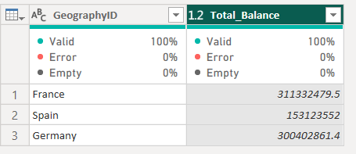

France has highest account balance and Spain has lowest among all.

1. Identify the top 5 customers with the highest Estimated Salary in the last quarter of the year. (SQL)

ANS:

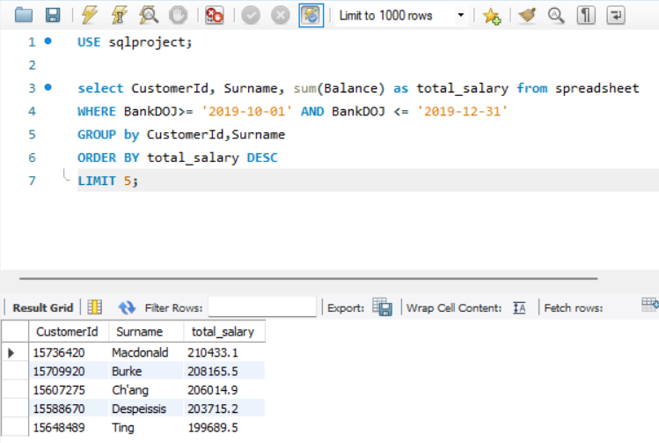

In the last quarter of the year Macdonald has the highest estimated Salary.

Burke, Ch’ang, Despeissis and Ting are the top other four.

1. Calculate the average number of products used by customers who have a credit card. (SQL)

ANS:

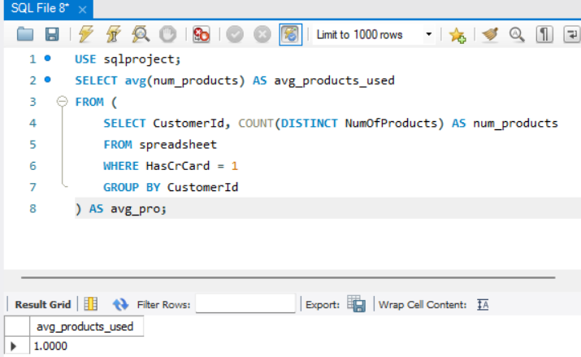

1. Compare the average credit score of customers who have exited and those who remain. (SQL)

ANS:

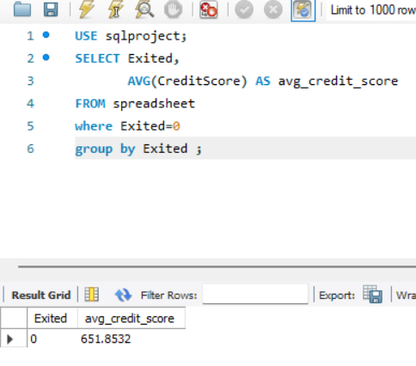 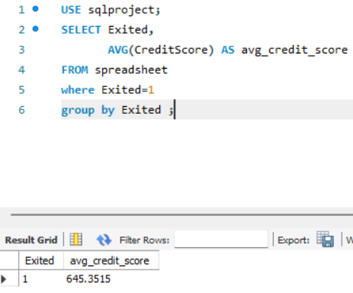e

* The average Credit score of the customer who has exited is 645.35.
* The average credit score of the Customer who has retained in the Bank is 651.85.

1. Determine the churn rate by gender for the most recent year in the dataset.

ANS: Churn rate= (Lost customer)/Total customer at the beginning of the period

In the most recent year 2019 churn rate of male (1) = (31/250)*100

= 12.4 %

In the most recent year 2019 churn rate of female (2) = (61/220)*100

= 27.7 %

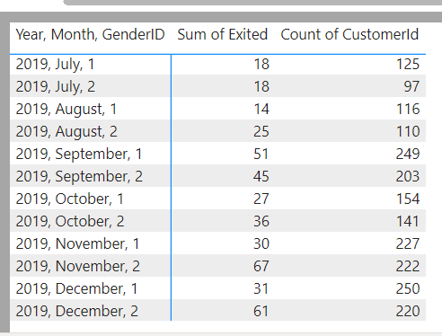

1. Which gender has a higher average estimated salary, and how does it relate to the number of active accounts? (SQL)

ANS:

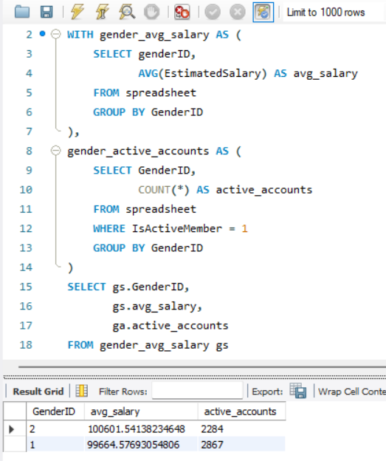

* Female has higher average of estimated salary amount that is 100.6K approx.
* The number of active members is 2k approx.
* Male has lower average of estimated salary amount that is 99.66k approx.
* The number of active members is 3k approx.
* Male are more active member than female.

1. Segment the customers based on their credit score and identify the segment with the highest exit rate. (SQL)

ANS:

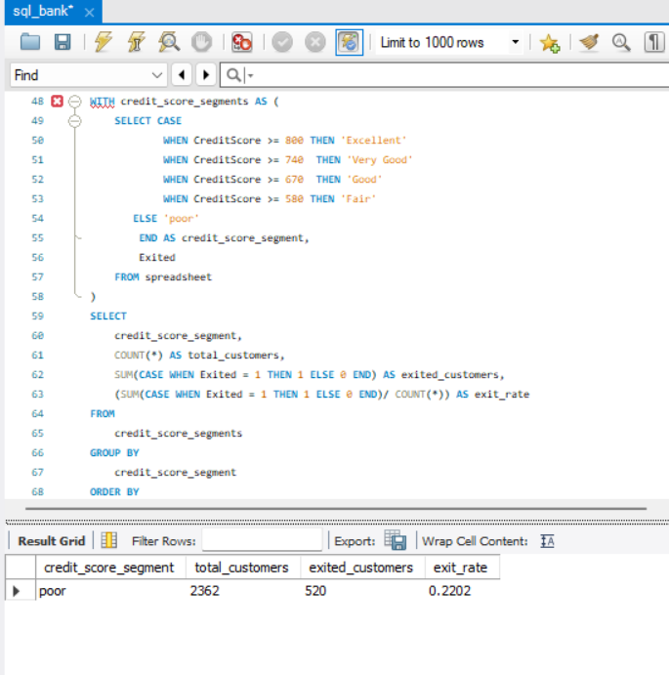

The poor credit score customer has the highest exit rate and the number of such customer is

520 out of 2362.

1. Find out which geographic region has the highest number of active customers with a tenure greater than 5 years. (SQL)

ANS: The geographic region has the highest number of active customers with a

tenure greater than 5 years is France 797.

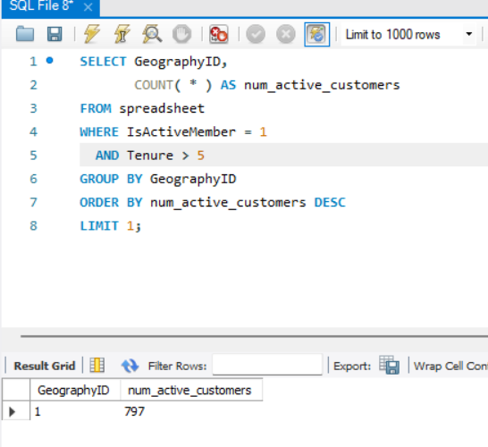

1. What is the impact of having a credit card on customer churn, based on the available data?

ANS:

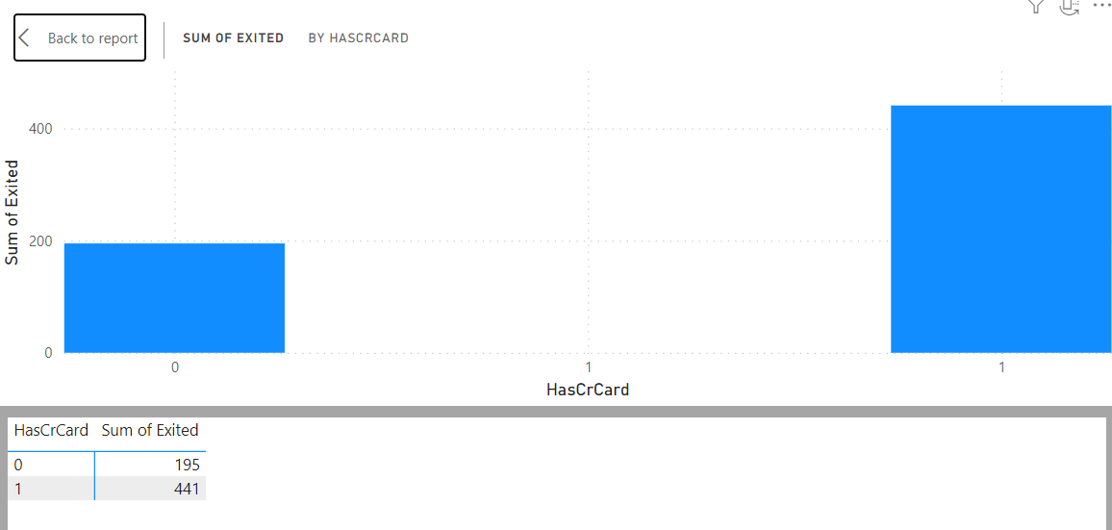

* The no of customer has credit card and exited is 441.
* The no of customer has not credit card and exited is 195.
* Means the number of exited customers is more in credit card holder one.

1. For customers who have exited, what is the most common number of products they have used?

ANS: The majority of customer who has exited have used only one product of the bank.

* The number of exited customers is less who have used more no of the bank products.

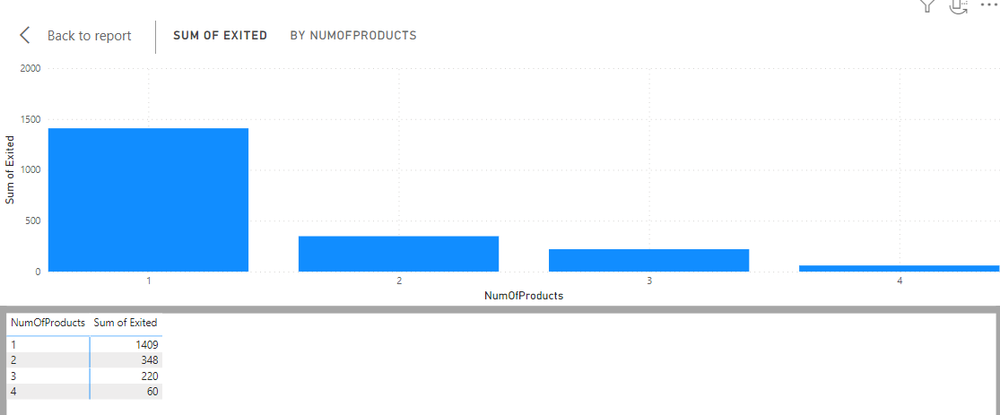

1. Examine the trend of customers joining over time and identify any seasonal patterns (yearly or monthly). Prepare the data through SQL and then visualize it.

ANS:

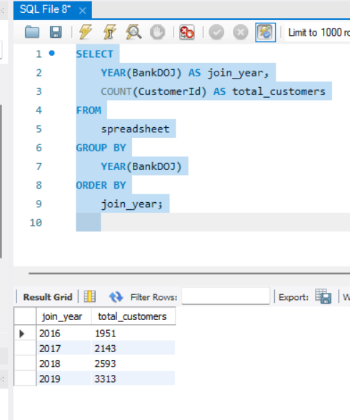

The number of customers has increased per year in the bank, that is a good sign. It is showing that customers getting satisfaction with the bank services and products.

From the data above, we could say that it is almost double in the 4 years of spain.

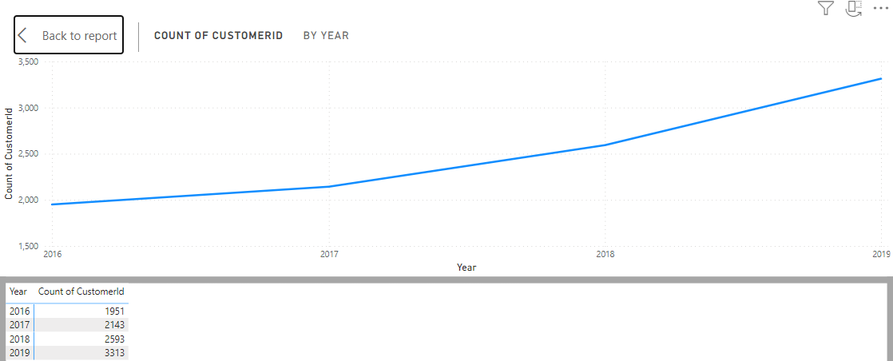

1. Analyze the relationship between the number of products and the account balance for customers who have exited.

ANS:

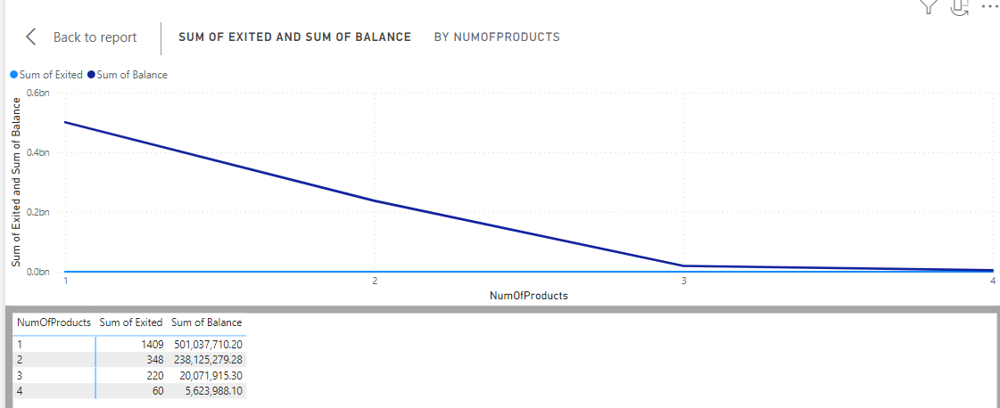

The sum of account balance of exited customers using one number of products is 501037710.20.

The sum of account balance of exited customers using 2 number of products is 238125279.28.

The sum of account balance of exited customers using 3 number of products is 20071915.30.

The sum of account balance of exited customers using 4 number of products is 5623988.10

1. Identify any potential outliers in terms of balance among customers who have remained with the bank.

ANS:

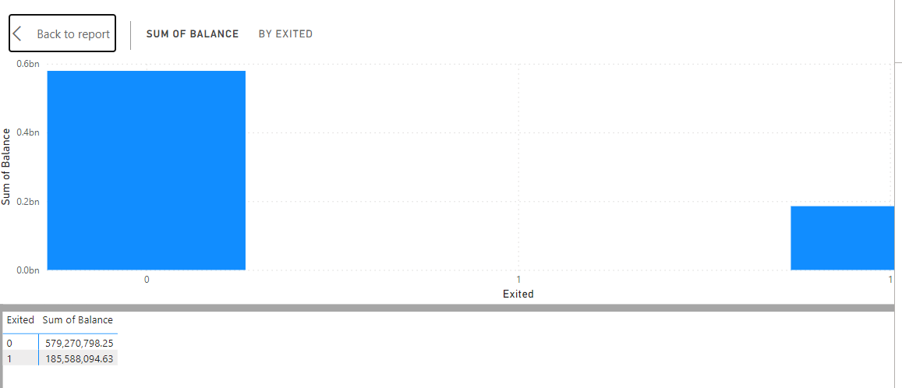

potential outliers in terms of balance among customers who have remained with the bank is 185588094.63.

1. How many different tables are given in the dataset, out of these tables which table only consists of categorical variables?

ANS: There are 7 tables are given in the dataset, out of these Bank_churn table consists categorical variables.

1. Using SQL, write a query to find out the gender-wise average income of males and females in each geography id. Also, rank the gender according to the average value. (SQL)

ANS:

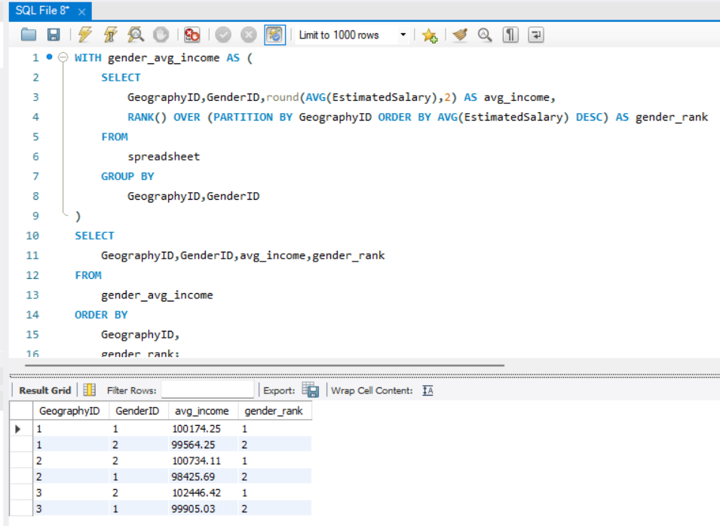

France male customer has highest average income among all countries and Germany male customers has lowest average income among all countries.

1. Using SQL, write a query to find out the average tenure of the people who have exited in each age bracket (18-30, 30-50, 50+).

ANS:

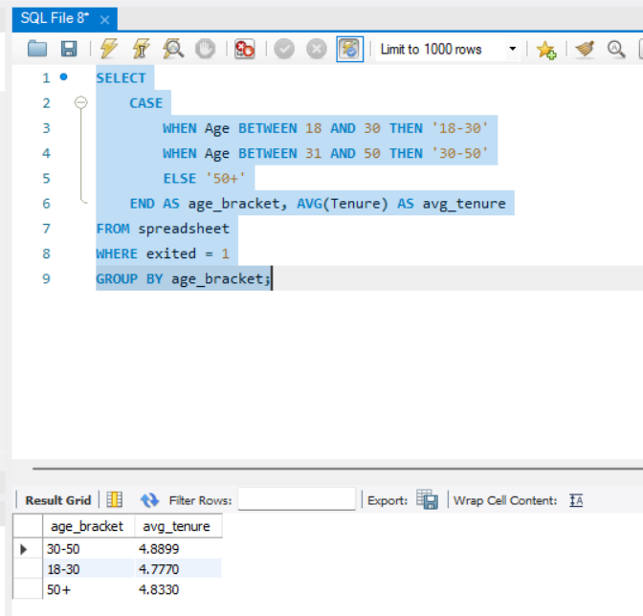

The average tenure of the customer who has exited

In age group 30 to 50 is 4.9.

The average tenure of the customer who has exited

In age group 18 to 30 is 4.8.

The average tenure of the customer who has exited

In age group 50 + is 4.8.

Over all their average tenure is constant that is 4.8.

1. Is there any direct correlation between salary and the balance of the customers? And is it different for people who have exited or not?

ANS:

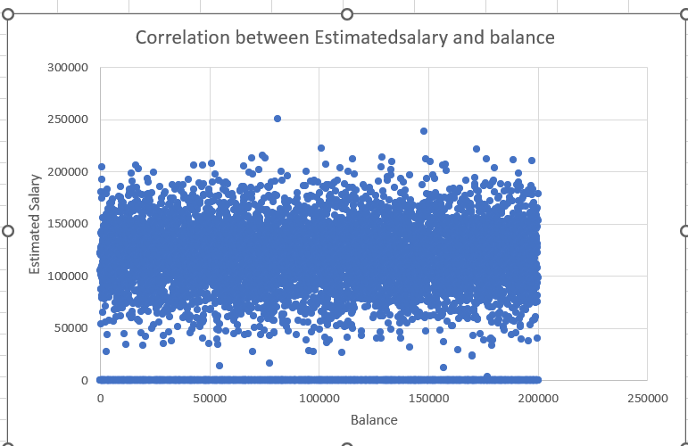

From scatter plot is look a constant relationship between both.

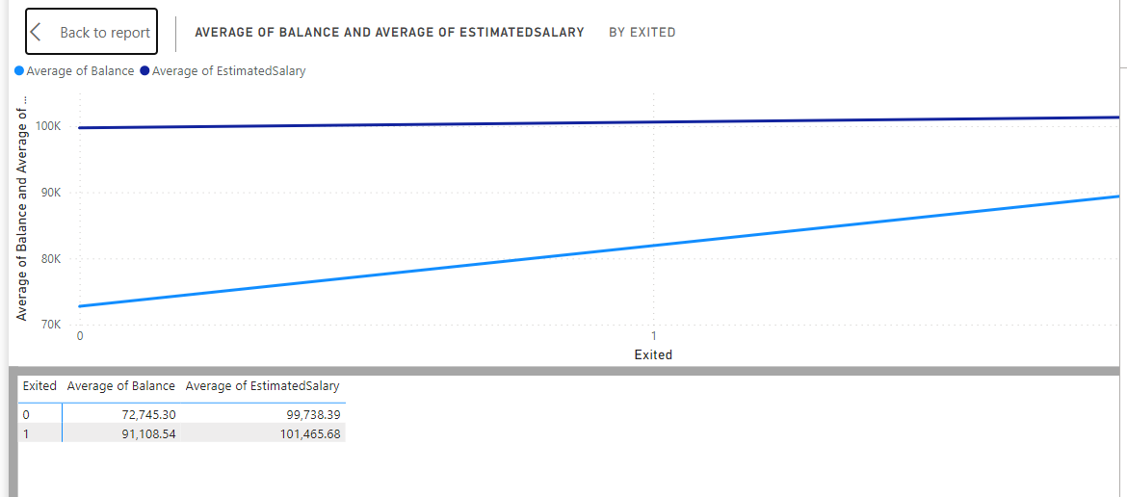

The average estimated salary of the exited and retained customers are greater than the average balance customers.

1. Is there any correlation between the salary and the Credit score of customers?

ANS:

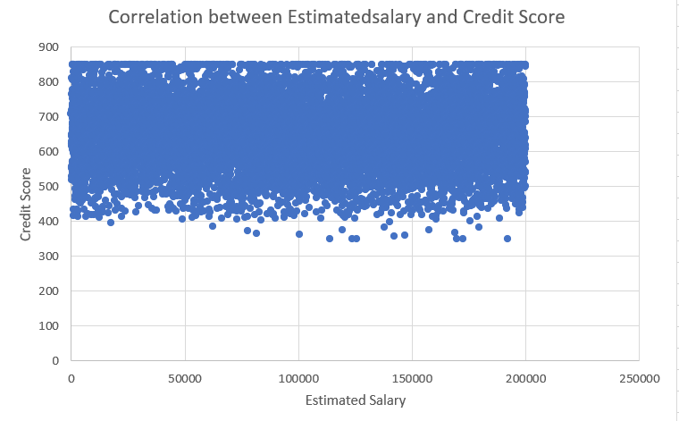

All estimated salary customers have credit score is in the range of 400 to 850.

Maximum number of customers have credit score in the range of 550 to 750 which is a good score.

1. Rank each bucket of credit score as per the number of customers who have churned the bank.

ANS: Below is the list of the rank of credit score as per number of customers who have churned the bank. Credit score 350 customer have 5 number of customers who has left the bank.

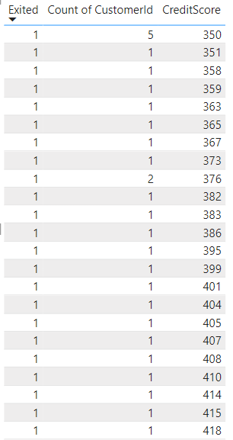

1. According to the age buckets find the number of customers who have a credit card. Also retrieve those buckets that have lesser than average number of credit cards per bucket.

ANS:

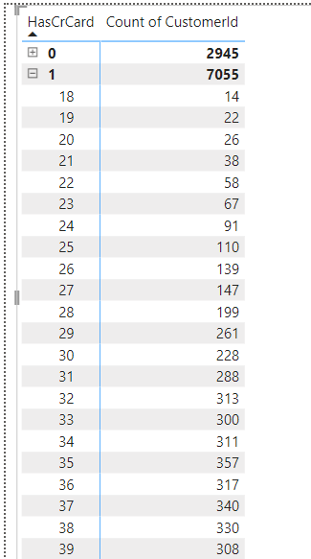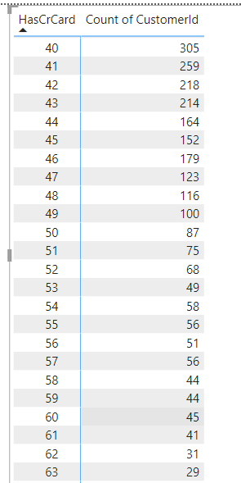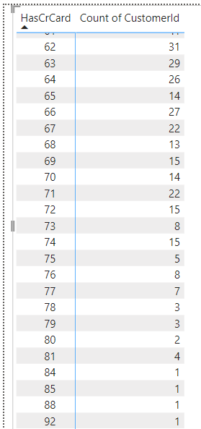

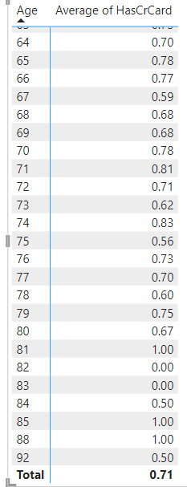

The is not any customers who has lesser then average no of credit cards.

1. Rank the Locations as per the number of people who have churned the bank and average balance of the customers.

ANS:

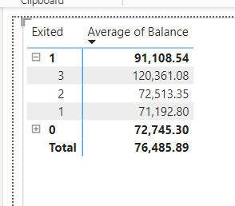

As per the location the number of people who have churned the bank and average balance of the customers: Germany is first, spain is second and France is third.

1. As we can see that the “CustomerInfo” table has the CustomerID and Surname, now if we have to join it with a table where the primary key is also a combination of CustomerID and Surname, come up with a column where the format is “CustomerID_Surname”.

ANS: I have used nested concatenated function for that

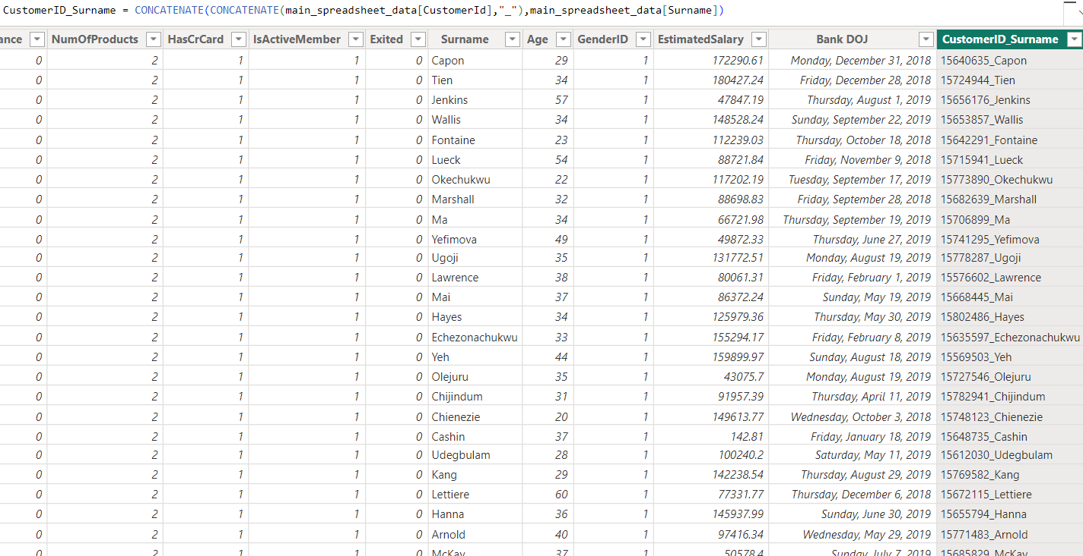

1. Without using “Join”, can we get the “ExitCategory” from ExitCustomers table to Bank_Churn table? If yes do this using SQL.

ANS: I have used subquery for that

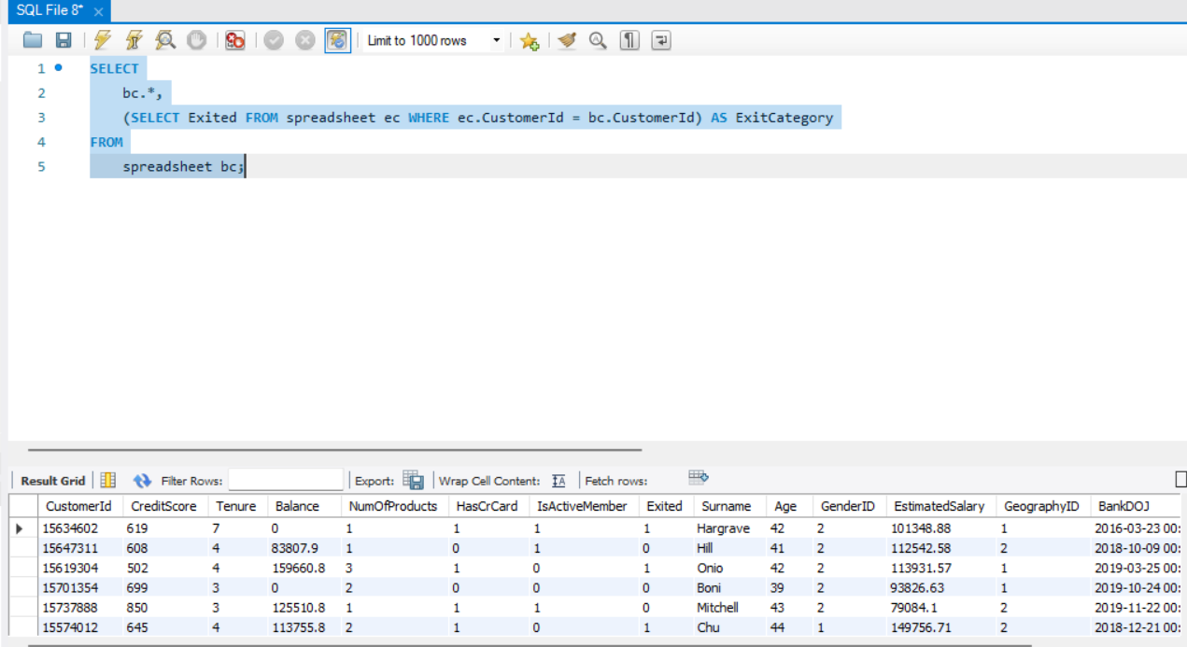

1. Were there any missing values in the data, using which tool did you replace them and what are the ways to handle them?

ANS: the was not any missing values in the data. For handling with missing values there are following tools in power bi:

Filtering: Exclude rows with missing values using the filter option in Power BI. You can filter out rows where specific columns have missing values, ensuring that only complete data is displayed.

Replace Values: Use the "Replace Values" option in the Power Query Editor to replace missing values with a specific value or a calculated value based on conditions.

Fill Down or Up: In the Power Query Editor, you can use the "Fill Down" or "Fill Up" options to fill missing values with the value from the previous or next row in a column.

Custom Columns: Create a custom column in Power Query Editor to fill missing values based on calculations or conditions from other columns in the dataset.

DAX Functions: Use DAX functions like IF, ISBLANK, COALESCE, or IFERROR to handle missing values in calculated columns or measures.

1. Write the query to get the customer IDs, their last name, and whether they are active or not for the customers whose surname ends with “on”.

ANS: Below is the details of the answer

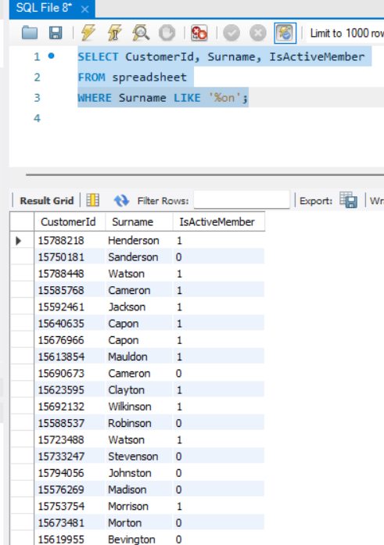

**Subjective Question:**

1. Customer Behaviour Analysis: What patterns can be observed in the spending habits of long-term customers compared to new customers, and what might these patterns suggest about customer loyalty?

ANS:

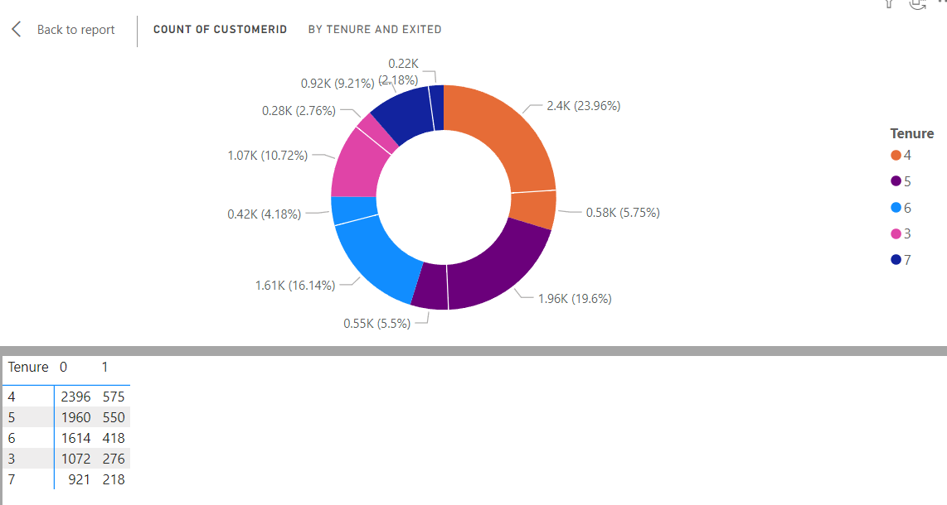

* The 4 years tenure customers have 5.75% of exit rate.
* The 5 years tenure customers have 5.5% of exit rate.
* The 6 years tenure customers have 4.18% of exit rate.
* The 3 years tenure customers have 2.76% of exit rate.
* The 7 years tenure customers have 2.18% of exit rate.

Means the oldest customers has more belief on bank.

1. Product Affinity Study: Which bank products or services are most commonly used together, and how might this influence cross-selling strategies?

* ANS: The customers using 1 number of product as well as using credit card is double than that of not using credit card.
* The customers using 2 numbers of product as well as using credit card is more than double than that of not using credit card.
* The customers using 4 number of products is very less.

We have to promote the numbers of products and credits cards in bank.

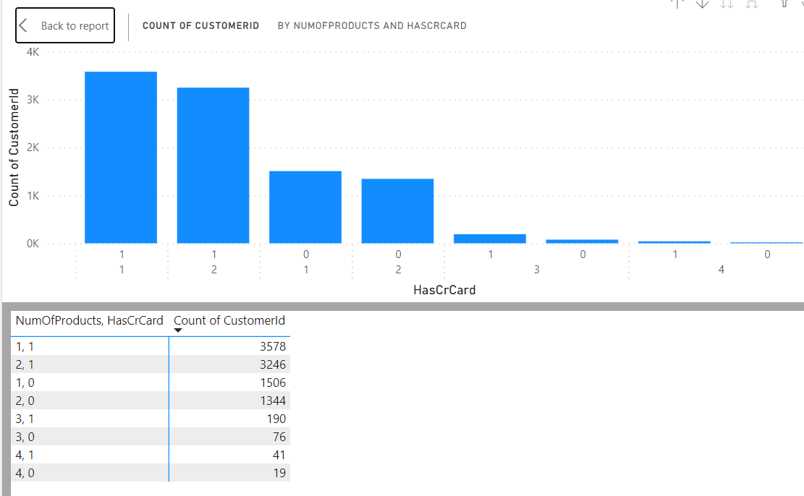

1. Geographic Market Trends: How do economic indicators in different geographic regions correlate with the number of active accounts and customer churn rates?

ANS:

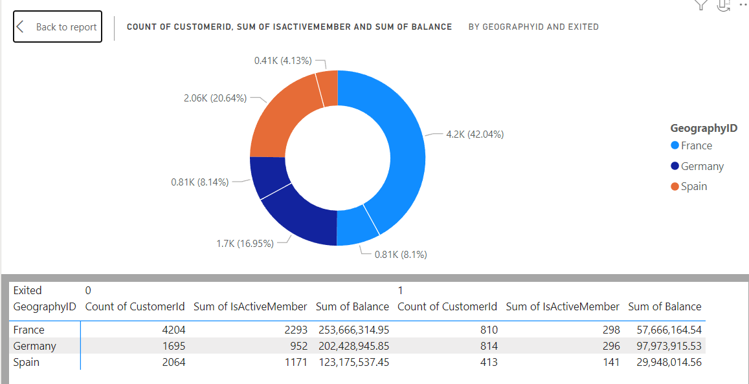

* France has the highest number of customers along with the highest number of active members.
* Germany has the lowest number of customers and the lowest number of active members.

As per the sum of balance France stands at first, Germany stands at second and Spain stands at third position.

As per the number of customers France stands at first, Spain stands at second and Germany stands at third position.

1. Risk Management Assessment: Based on customer profiles, which demographic segments appear to pose the highest financial risk to the bank, and why?

ANS:

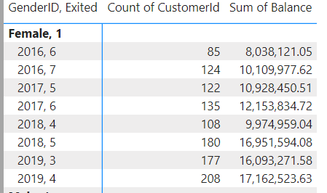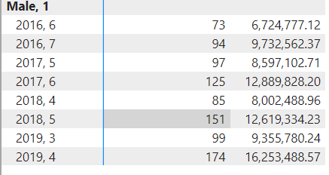

The female customers joined in 2019 having 3 to 4 years of tenure appear to pose the highest financial risk because their total balance salary is very high.

The male customer joined in 2019 having 3 to 4 years of tenure appear to pose the highest financial risk because their total balance salary is very high.

It would affect the over all revenue of the bank.

1. Customer Tenure Value Forecast: How would you use the available data to model and predict the lifetime (tenure) value in the bank of different customer segments?

ANS:

* The number of customers exited in year 2019 is 382 in which 135 was active members, they had 4 years of tenure.
* The number of customers exited in year 2019 is 276 in which 103 was active members they had 3 years of tenure.
* The number of customers exited in yea 2016 and tenure 6, 7 years is less.
* Over all we can say that the exit number of higher tenure customer is less and active

members in them are minimal.

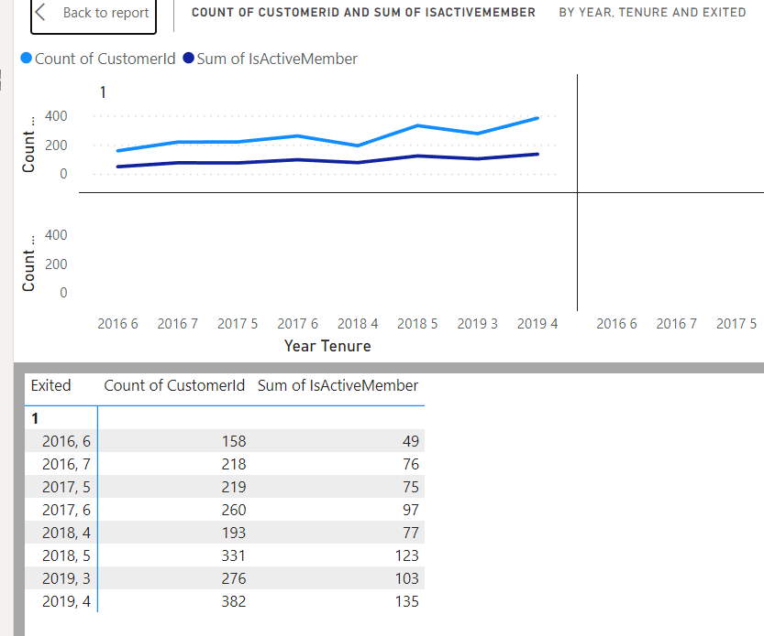

1. Marketing Campaign Effectiveness: How could you assess the impact of marketing campaigns on customer retention and acquisition within the dataset? What extra information would you need to solve this?

ANS:

Define Metrics: Define metrics to measure customer retention and acquisition. For retention, you can use metrics like customer churn rate or customer retention rate. For acquisition, you can use metrics like the number of new customers acquired or the customer acquisition cost (CAC).

Identify Marketing Campaign Data: Identify the relevant data in your dataset related to marketing campaigns, such as campaign start and end dates, campaign type, target audience, and associated costs.

Link Campaign Data with Customer Data: Link the marketing campaign data with customer data to understand which customers were targeted by each campaign and how they responded.

Measure Impact: Use the defined metrics to measure the impact of each marketing campaign on customer retention and acquisition. Compare the performance of customers targeted by the campaign with those who were not targeted.

Statistical Analysis: Use statistical analysis techniques to determine the statistical significance of the impact of each campaign on customer retention and acquisition.

Visualization: Use visualizations such as line charts, bar charts, and heat maps to visualize the impact of marketing campaigns on customer retention and acquisition over time.

Extra Information Needed:

Detailed campaign data: Start and end dates, campaign type, target audience, and costs.

Customer data: Information on customer segments, behaviour, and responses to campaigns.

Timeframe: Data over a specific timeframe to analyse the impact of campaigns over time.

Control Group: Data on customers who were not targeted by any campaigns to compare with the campaign's impact on the targeted group.

1. Customer Exit Reasons Exploration: Can you identify common characteristics or trends among customers who have exited that could explain their reasons for leaving?

ANS:

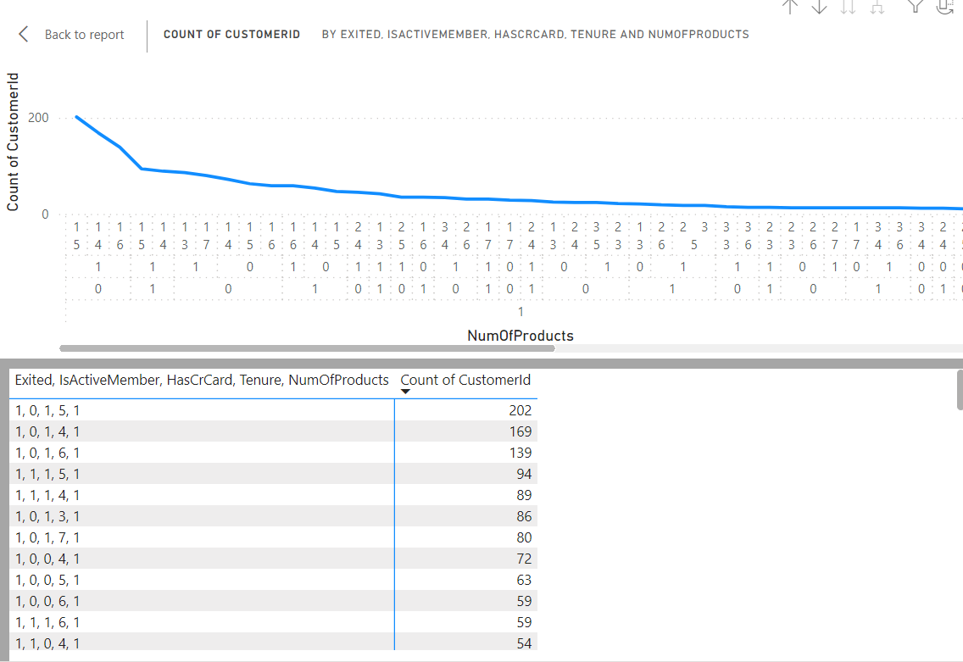

* The highest number of customers who exited the bank was not the active members.
* The tenure of the highest number of exited customers are 4 and 5 years.
* The highest number of exited customers are involving in only one type of bank product.

1. Are 'Tenure', 'NumOfProducts', 'IsActiveMember', and 'EstimatedSalary' important for predicting if a customer will leave the bank?

ANS:

Yes,

'Tenure', 'NumOfProducts', 'IsActiveMember', and 'EstimatedSalary' can be important factors for predicting if a customer will leave the bank. Here's a brief explanation of each:

Tenure: This refers to how long a customer has been with the bank. Generally, the longer a customer has been with the bank, the less likely they are to leave. Tenure can indicate loyalty and satisfaction with the bank's services.

NumOfProducts: This refers to the number of bank products (like accounts, loans, etc.) that a customer has. Customers with more products might be more engaged with the bank and thus less likely to leave, or conversely, they might have higher exposure to dissatisfaction if they encounter issues with multiple products.

IsActiveMember: This indicates whether a customer is an active member of the bank. Active members are more likely to stay because they are actively using the bank's services.

EstimatedSalary: While not directly related to banking behavior, salary can indirectly impact a customer's likelihood to leave. For example, customers with higher salaries might have more financial stability and be less likely to switch banks.

1. Utilize SQL queries to segment customers based on demographics and account details.

ANS:

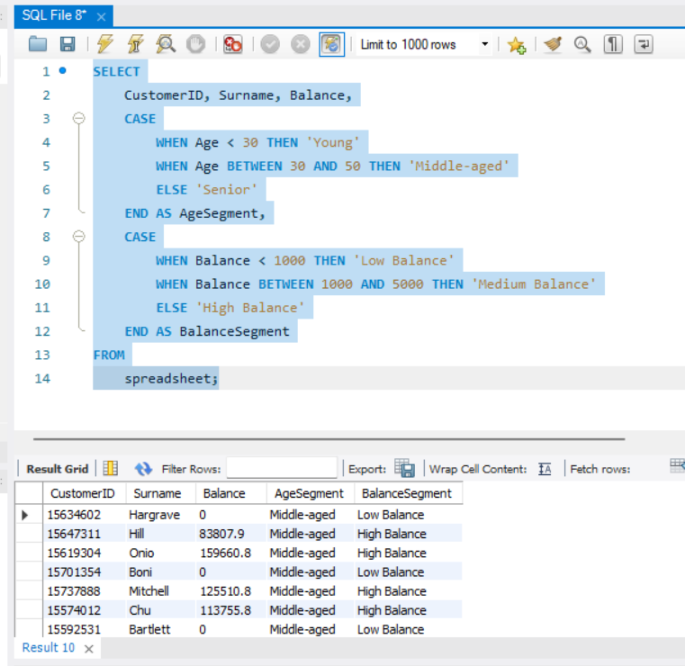

1. How can we create a conditional formatting setup to visually highlight customers at risk of churn and to evaluate the impact of credit card rewards on customer retention?

ANS:

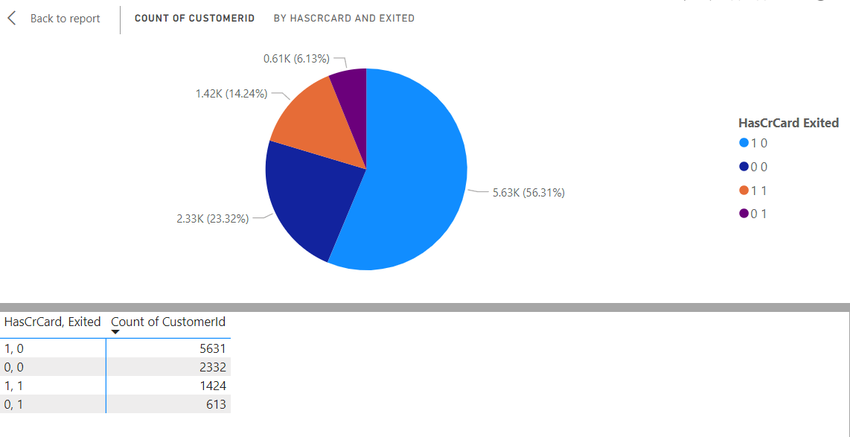

Define Metrics: Define metrics to measure customer retention, such as the churn rate or customer retention rate.

Data Analysis: Analyse the data to identify customers at risk of churn. Use tools like Power BI to visualize the data and identify trends or patterns.

Conditional Formatting: Use conditional formatting in Power BI to visually highlight customers at risk of churn. You can use colour scales or icon sets to indicate the level of risk.

Impact of Credit Card Rewards: Analyse the impact of credit card rewards on customer retention. Compare the retention rates of customers who are enrolled in the rewards program with those who are not.

Visualization: Use Power BI to create visualizations that show the impact of credit card rewards on customer retention. This can include line charts, bar charts, or heat maps.

Monitor and Adjust: Continuously monitor the data and adjust your strategies as needed. Use the insights gained from the analysis to improve customer retention efforts.

1. What is the current churn rate per year and overall as well in the bank? Can you suggest some insights to the bank about which kind of customers are more likely to churn and what different strategies can be used to decrease the churn rate?

ANS:

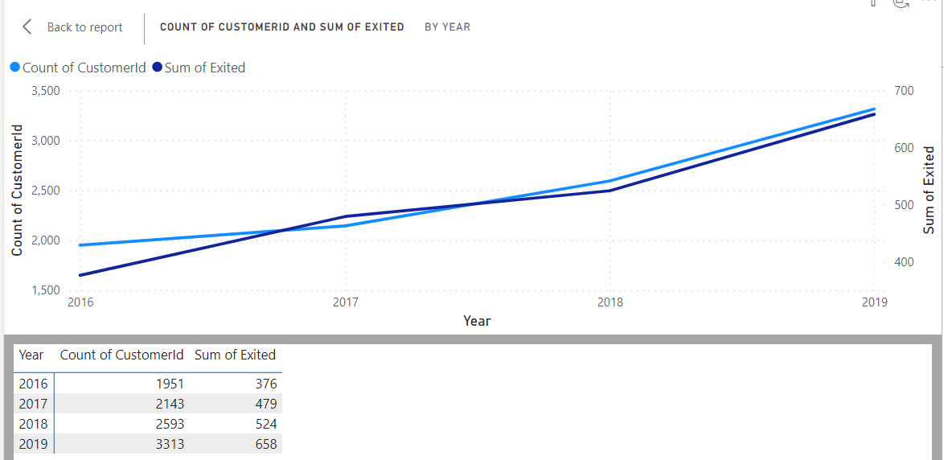

❑ The highest number of customers who exited the bank was not the active members.

❑ The tenure of the highest number of exited customers are 4 and 5 years.

❑ The highest number of exited customers are involving in only one type of bank product.

These types of customers are more likely to churn.

The below are the different strategies for decreasing churn rate:

Personalized Communication: Tailor communications to individual customers based on their banking behaviour and preferences. Personalized offers and messages can increase engagement and loyalty.

Improve Customer Service: Provide excellent customer service through all channels, including in-branch, online, and over the phone. Quick resolution of issues and friendly service can improve customer satisfaction.

Offer Financial Incentives: Provide incentives such as lower fees, higher interest rates on savings accounts, or cash rewards for staying with the bank. These incentives can encourage customers to remain loyal.

Enhance Digital Banking Services: Improve online and mobile banking platforms to make them more user-friendly and efficient. Offering features such as mobile check deposit, bill pay, and budgeting tools can increase customer satisfaction.

Educational Resources: Provide educational resources to help customers make informed financial decisions. This can include articles, videos, and webinars on topics like saving, investing, and managing debt.

Cross-Sell Relevant Products: Identify opportunities to cross-sell relevant products or services based on customer needs and preferences. However, be careful not to be too aggressive, as this can lead to customer dissatisfaction.

Feedback and Surveys: Regularly solicit feedback from customers through surveys and feedback forms. Use this information to identify areas for improvement and make changes to reduce churn.

Reward Loyalty: Implement a loyalty program that rewards customers for their continued business. This can include points that can be redeemed for cash back, gift cards, or other rewards.

1. Create a dashboard incorporating all the KPIs and visualization-related metrics. Use a slicer in order to assist in selection in the dashboard.

ANS:

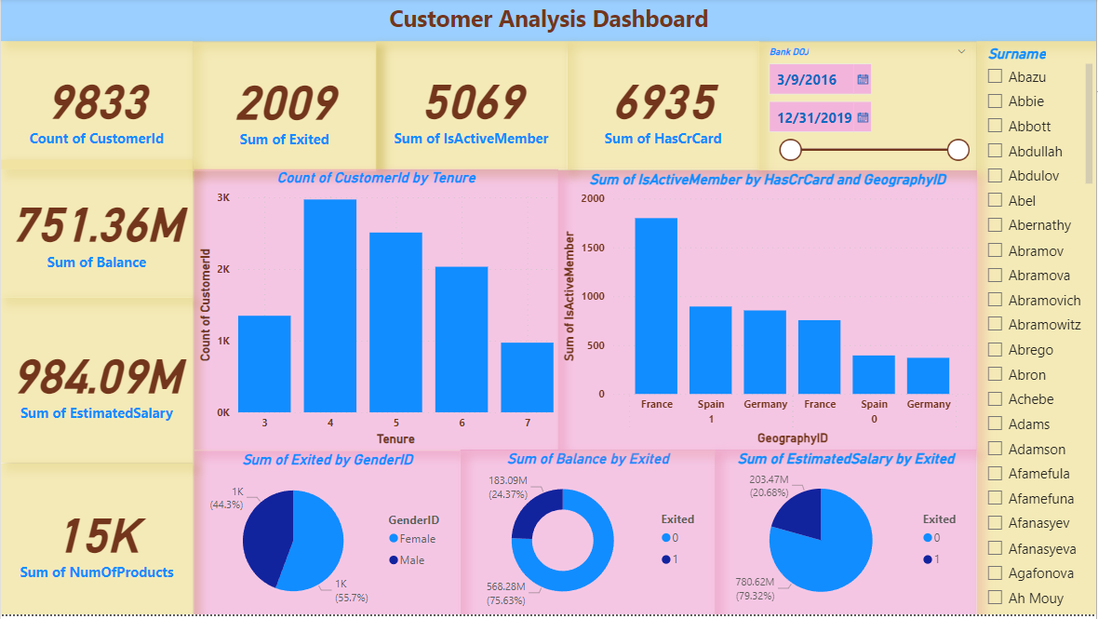

1. How would you approach this problem, if the objective and subjective questions weren't given?

ANS: Creating a dashboard without specific objective and subjective questions can be challenging as the dashboard's design and content should align with the purpose and goals of the dashboard. However, here's a general approach you can take:

Identify the Purpose: Determine the overarching goal of the dashboard. Is it to provide an overview of key metrics, track progress towards goals, analyze trends, or something else?

Identify the Audience: Understand who will be using the dashboard. Their roles, responsibilities, and information needs will influence the design and content.

Select Relevant Metrics: Choose metrics that are important to the audience and align with the dashboard's purpose. These could include KPIs, performance indicators, or other relevant data points.

Choose Visualization Types: Select appropriate visualizations (e.g., charts, graphs, tables) to represent the selected metrics effectively. Consider using a mix of visualizations to provide a comprehensive view.

Design the Layout: Organize the visualizations on the dashboard in a logical and intuitive manner. Group related visualizations together and use space wisely.

Add Interactivity: Incorporate interactive elements such as filters, slicers, and drill-downs to allow users to explore the data further and gain deeper insights.

Provide Context: Include titles, subtitles, and annotations to provide context and guide users through the dashboard. Use text boxes to explain key insights or trends.

Ensure Accessibility: Ensure that the dashboard is accessible to all users, including those with disabilities. Use color schemes and design elements that enhance readability and usability.

Test and Iterate: Test the dashboard with actual users and gather feedback. Iterate on the design based on feedback to improve usability and effectiveness.

Maintain and Update: Regularly update the dashboard with new data and metrics to keep it relevant and useful to users.

1. In the “Bank_Churn” table how can you modify the name of the “HasCrCard” column to “Has_creditcard”?

ANS: To modify the name of the "HasCrCard" column to "Has_creditcard" in the "Bank_Churn" table, you can use the ALTER TABLE statement along with the RENAME COLUMN clause. Here's how you can do it:

ALTER TABLE Bank_Churn

RENAME COLUMN HasCrCard TO Has_creditcard;

This statement will rename the column "HasCrCard" to "Has_creditcard" in the "Bank_Churn" table.